1.Write a query to Display the product details (product_class_code, product_id, product_desc, product_price,) as per the following criteria and sort them in descending order of category: a. If the category is 2050, increase the price by 2000 b. If the category is 2051, increase the price by 500 c. If the category is 2052, increase the price by 600. Hint: Use case statement. no permanent change in table required. (60 ROWS) [NOTE: PRODUCT TABLE]

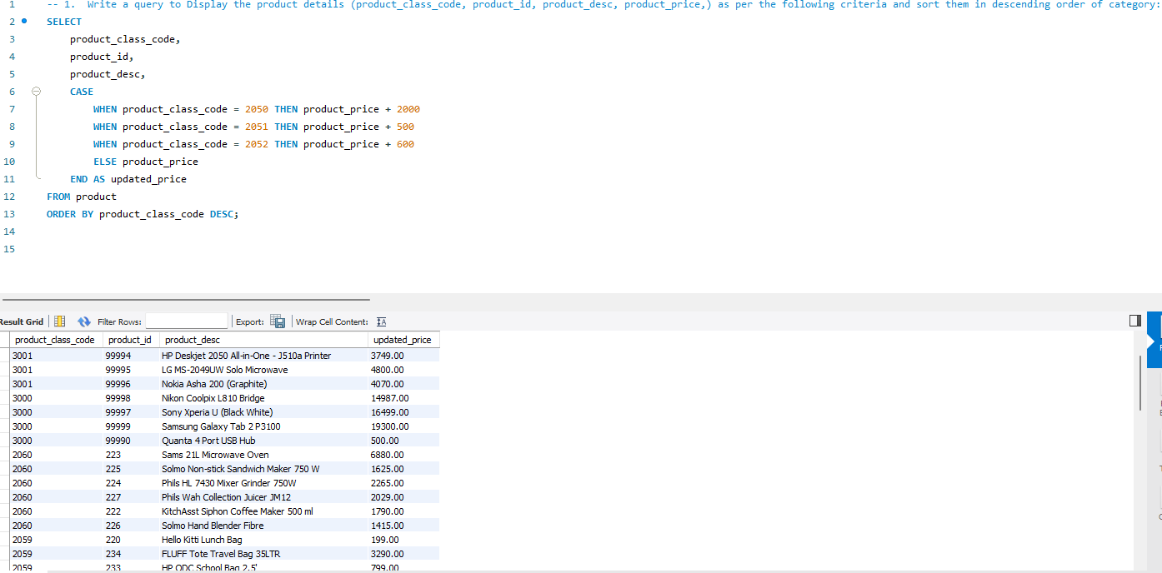

2.Write a query to display (product_class_desc, product_id, product_desc, product_quantity_avail ) and Show inventory status of products as below as per their available quantity: a. For Electronics and Computer categories, if available quantity is <= 10, show 'Low stock', 11 <= qty <= 30, show 'In stock', >= 31, show 'Enough stock' b. For Stationery and Clothes categories, if qty <= 20, show 'Low stock', 21 <= qty <= 80, show 'In stock', >= 81, show 'Enough stock' c. Rest of the categories, if qty <= 15 – 'Low Stock', 16 <= qty <= 50 – 'In Stock', >= 51 – 'Enough stock' For all categories, if available quantity is 0, show 'Out of stock'. Hint: Use case statement. (60 ROWS) [NOTE: TABLES TO BE USED – product, product_class]

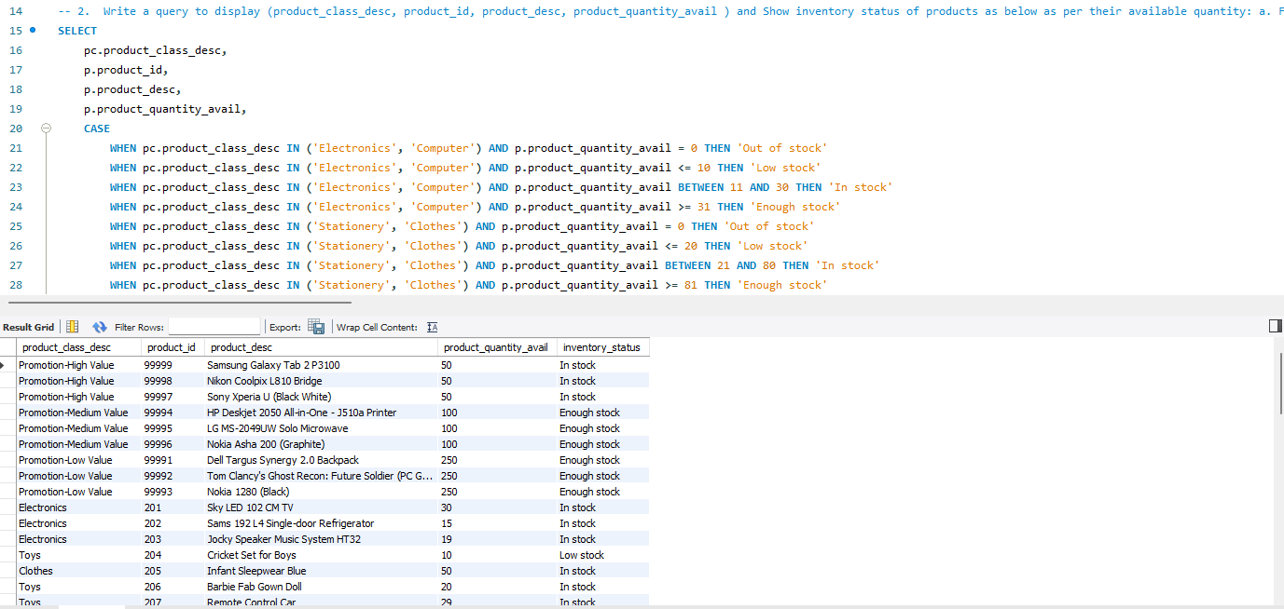

3.Write a query to Show the count of cities in all countries other than USA & MALAYSIA, with more than 1 city, in the descending order of CITIES. (2 rows) [NOTE: ADDRESS TABLE, Do not use Distinct]

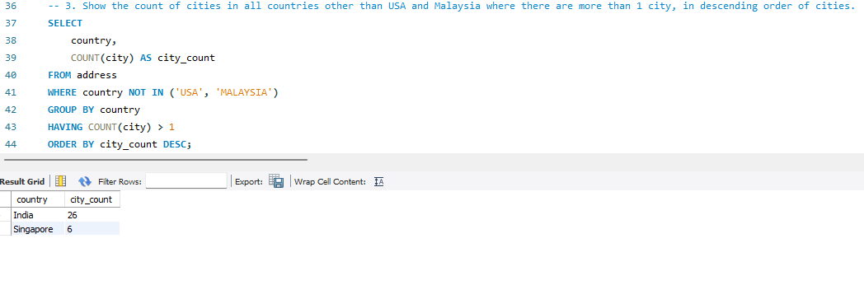

4.Write a query to display the customer_id,customer full name ,city,pincode,and order details (order id, product class desc, product desc, subtotal(product_quantity * product_price)) for orders shipped to cities whose pin codes do not have any 0s in them. Sort the output on customer name and subtotal. (52 ROWS) [NOTE: TABLE TO BE USED - online_customer, address, order_header, order_items, product, product_class]

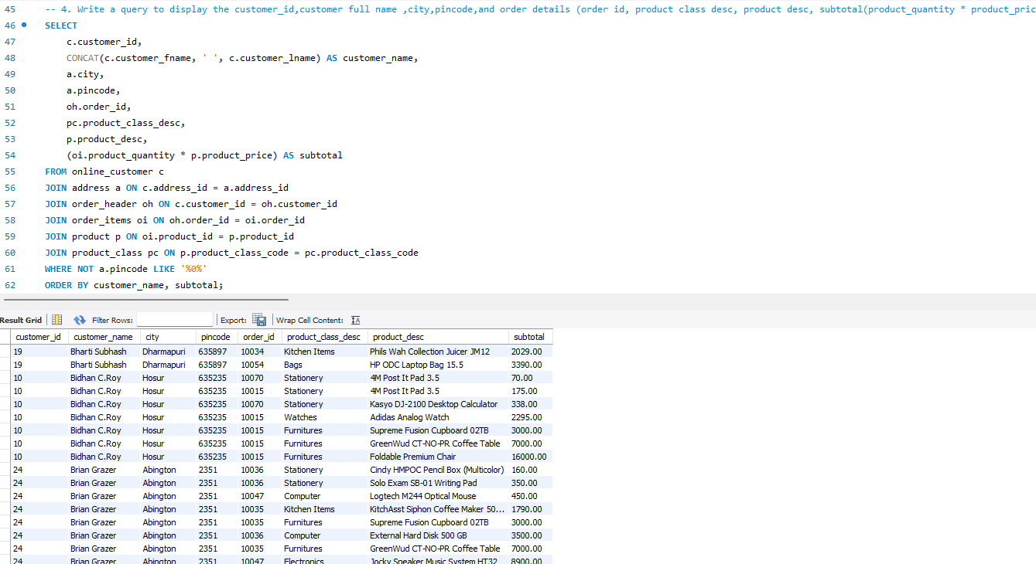52 rows were expected but I manually checked the data for pin code it does not have any zeroes on it in the output.

5.Write a Query to display product id,product description,totalquantity(sum(product quantity) for an item which has been bought maximum no. of times (Quantity Wise) along with product id 201. (USE SUB-QUERY) (1 ROW) [NOTE: ORDER_ITEMS TABLE, PRODUCT TABLE]

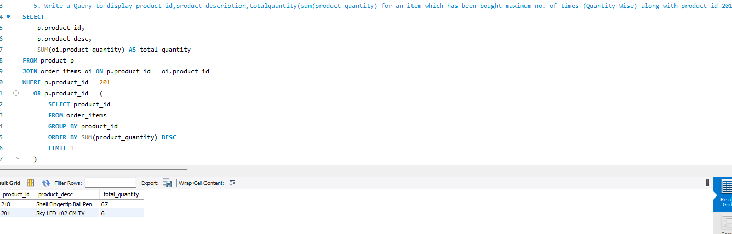2 rows are returned since the Product id 201 doesn't have maximum quantities sold